Web Accessibility

1. We are already doing accessible websites and apps, but we don’t the term. Like responsive design is also part of accessibility.
2. If user is in bright place like in sunny, brightness of app or device brightness can help.
3. We should have to choose the colors based on color blindness. Generally 1 in 12 and 1 in 200 women’s available color blindness.
4. 5% of population is color blindness.

If same contrast of red and green, people will confuse on color if they color blindness.

1. Contrast/ Lighting can effect on the colors.

Typography & Accessibility:

1. Font size should be 16px to 20px, use em for based on devics size
2. Line of content should be not toolon and not too short, it should be based on the devices width. 66char aprox
3. Avoid justify text ..extra space can create proble, who has dexlexia
4. Left alighted is good
5. Avoid all caps
6. These are suggestion not rules

Accessible form design

1. Required to know what are the fields in form
2. It helps in cognitive load to user
3. How many char are required , is it required fields are not, that’s help to not create cognitive load to user
4. Write proper description of text or input label
5. Warnings and suggestion should be very clear and it should not be in colors due color blindness issue here.
6. Warning should be like below

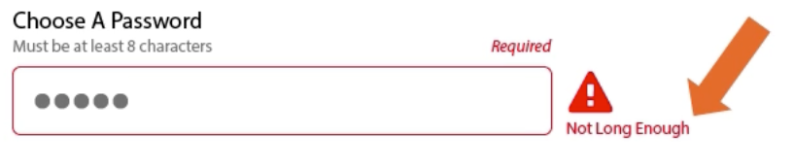

touch interection :

1. touch tragte should 44px to 48px, really should same thoumb.
2. Should ne eenugh space in targate
3. User error decresee by touch
4. Focus for user, who wanted to type by keybord .
5. Motion and desiness, when they do web surfing

* 40% over age 40
* we don’t kow exactly
* motion of dives
* transform of divs
* Every single transform or motion should have purpose, otherwise don’t do it.
* Do something user can stop animation if they wanted to do
* We always desing our website for calm cool and for happy peaples.
* But e should have design the website for panic, crises driven pesrons
* Panic peaples are looking for required details.

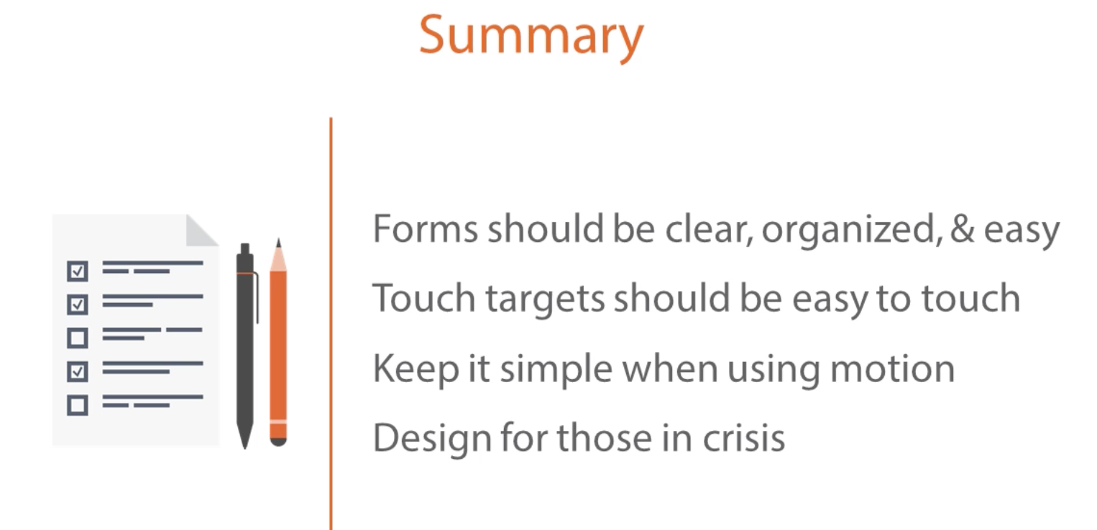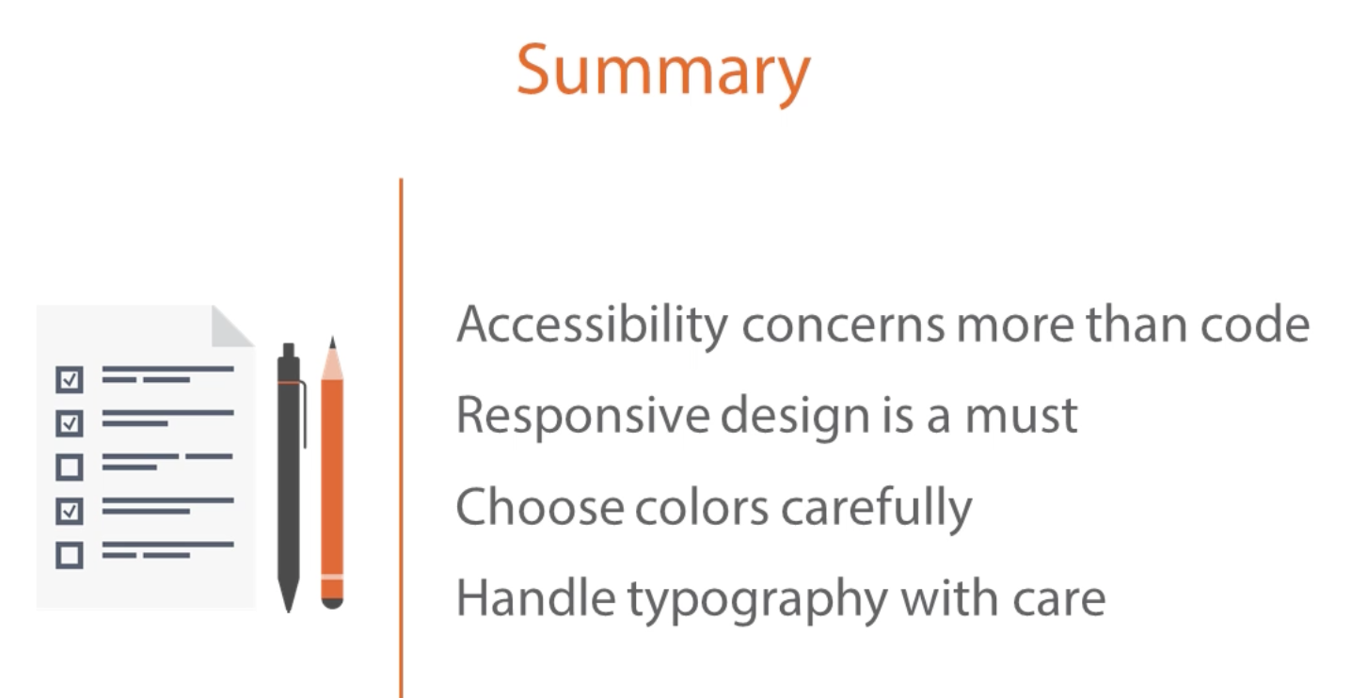

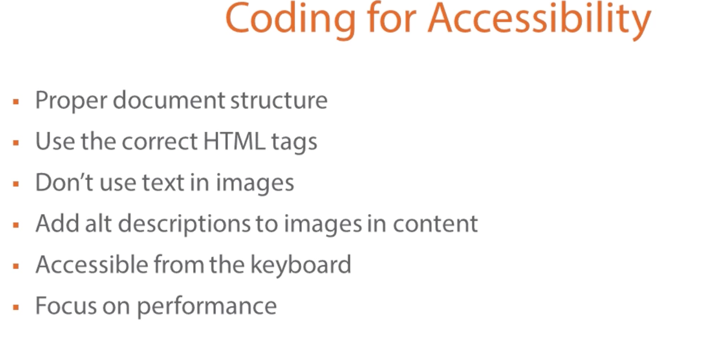

proper document design – if remove CSS, text should per display property in websites. Content should be good.

1. H2 heading should have parent of h1 , h3 should have parent of h2 and so on.
2. No heading should not be skip.

**Images & accessibility**

1. For those who can not see the images, need to provide description of images for color blindness peoples.
2. Chart kind of images ,we can provide little long description.
3. Can be ARIA attribute for description of images

**Content & accessibility**

1. we have to have skip to main content for who wanted to go by keyboard.
2. We should provide transcript content for hearing issues for adio
3. For video – we should provide caption content for who have hearing issues or not able to understand the language for vision or hearing issues
4. read more link is required to have
5. Don’t use **read more , use** read more about me or read more product

**HTML attributes & accessibility**

1. Tabindex can add into tag that will help doing from keyboard

Web from

1. Grouping large section is good, need to write legend for knowing the form name

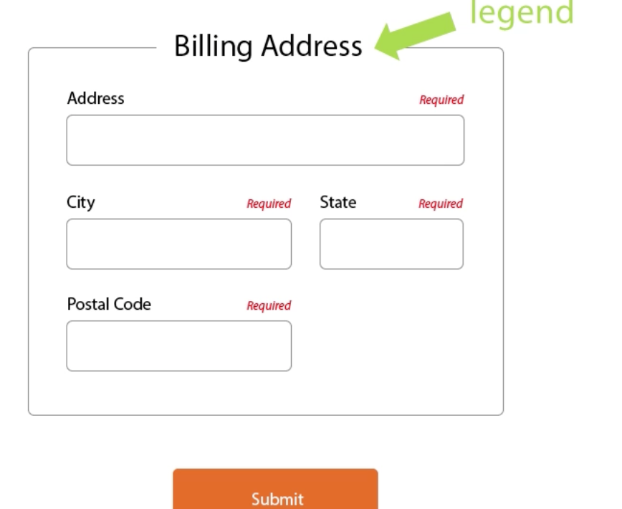

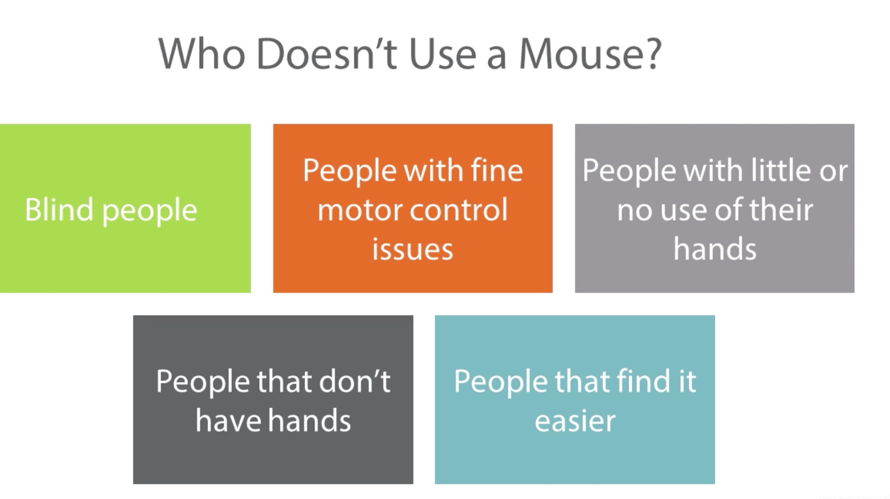

use can use only keybord

1. User can see by focusing the divs or attributes by keyboard

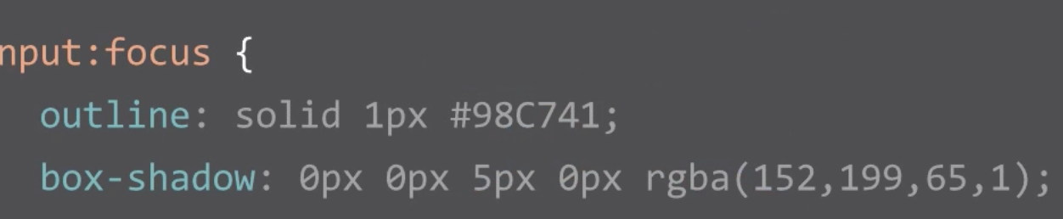

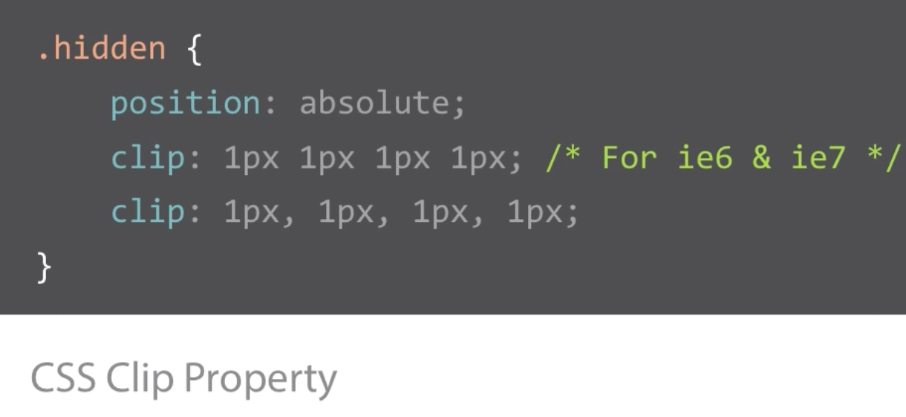



Performance and accessibility

1. Keep file size small
2. Limit http request
3. Imange compression technique
4. JPEG mini,.com , tinypng.com
5. Image sprite – reduces http
6. Use SVG, thy are small

Progressive and enhancement

1

. 

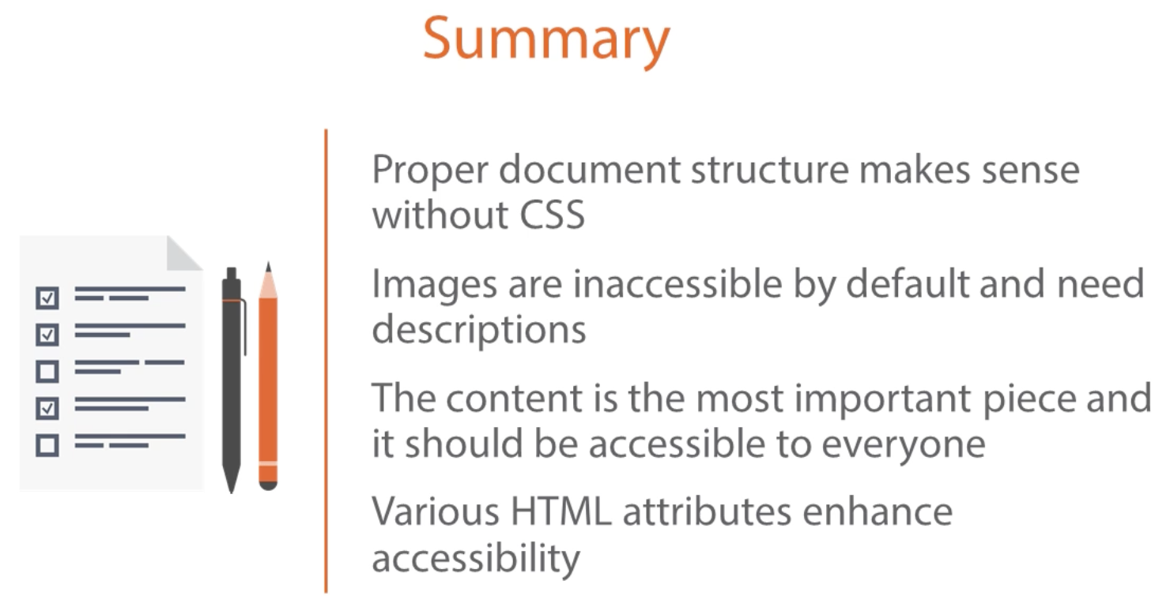

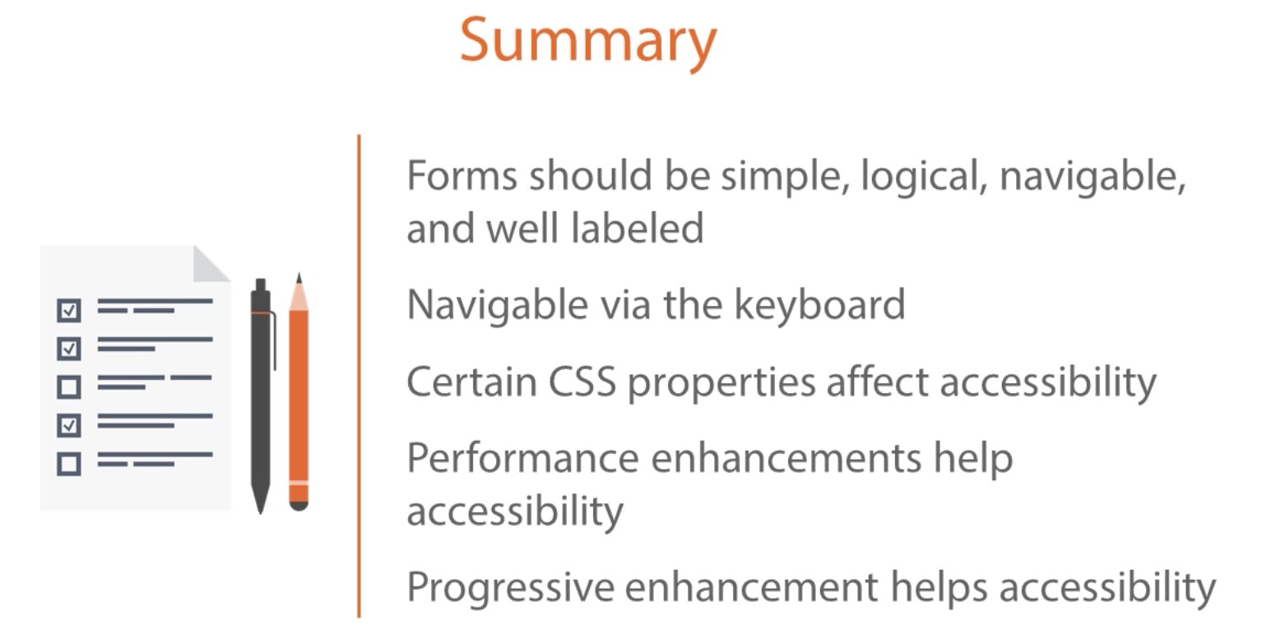

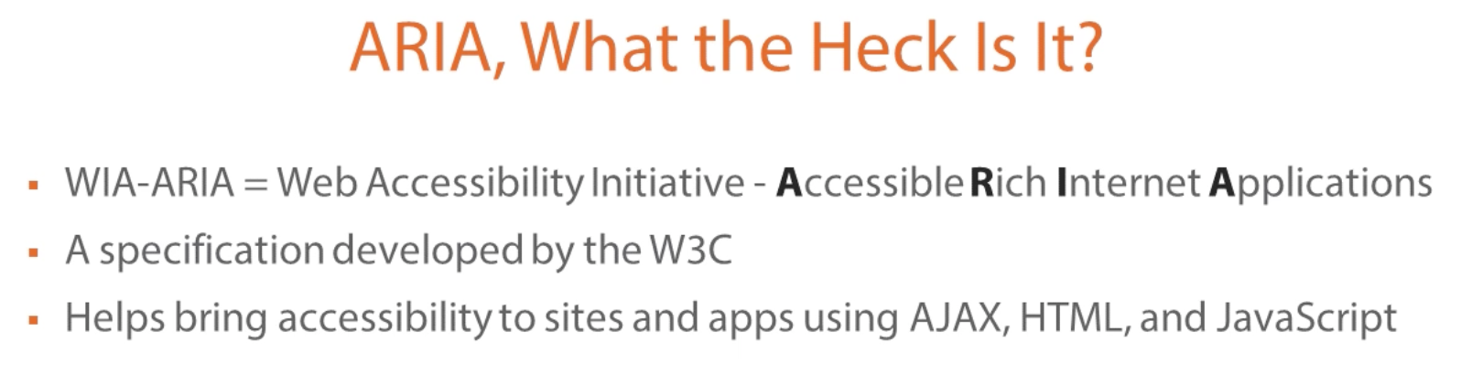

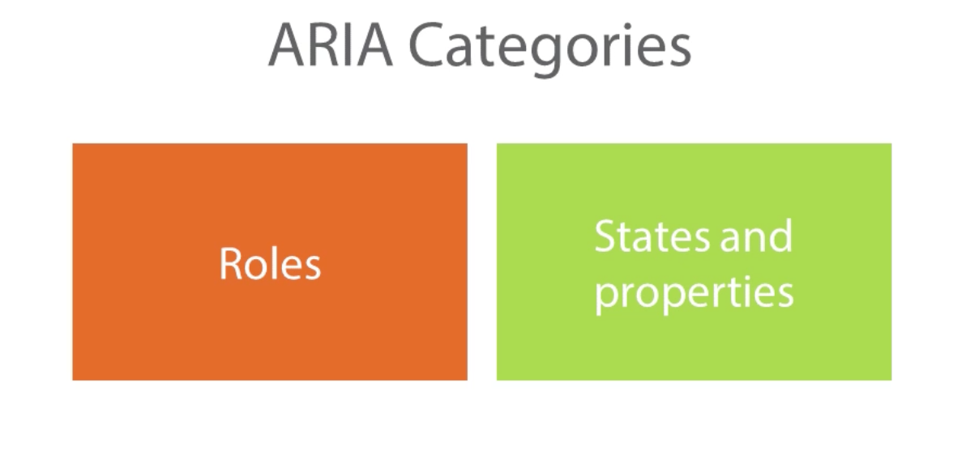

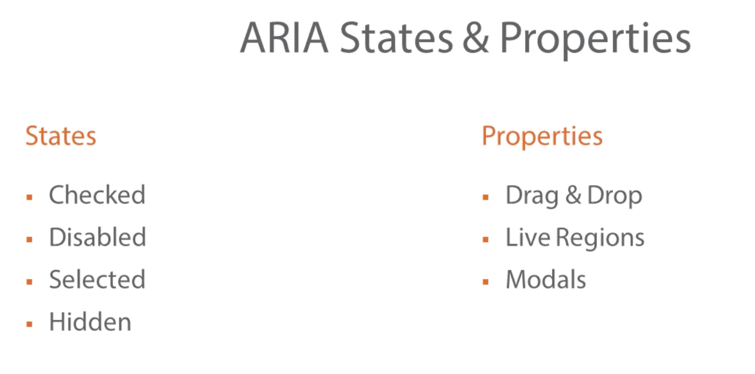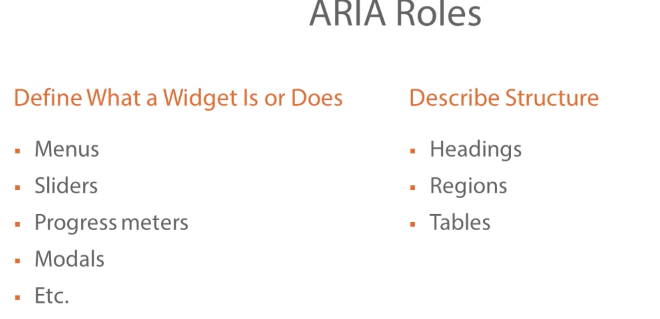

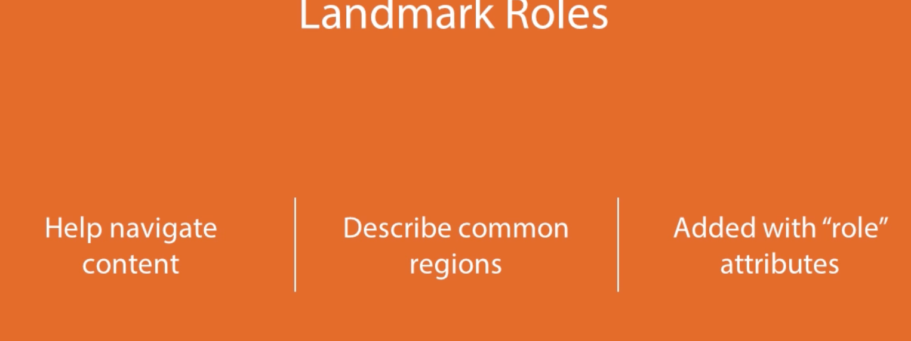

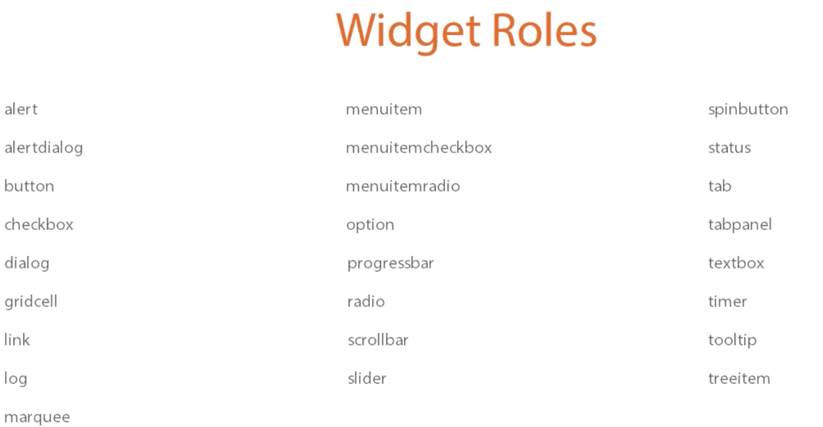

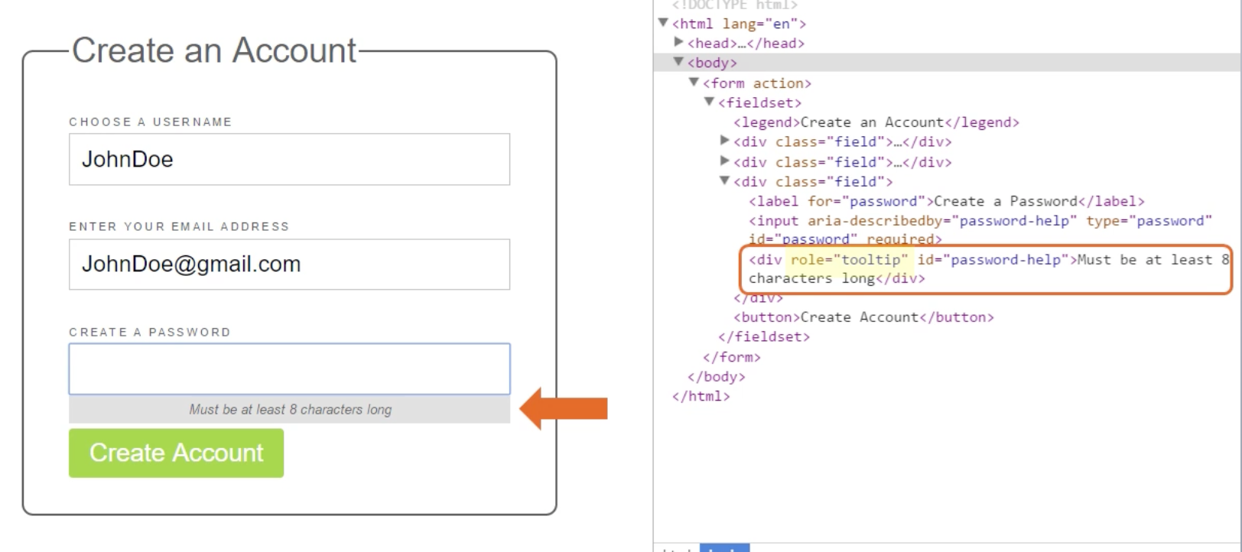

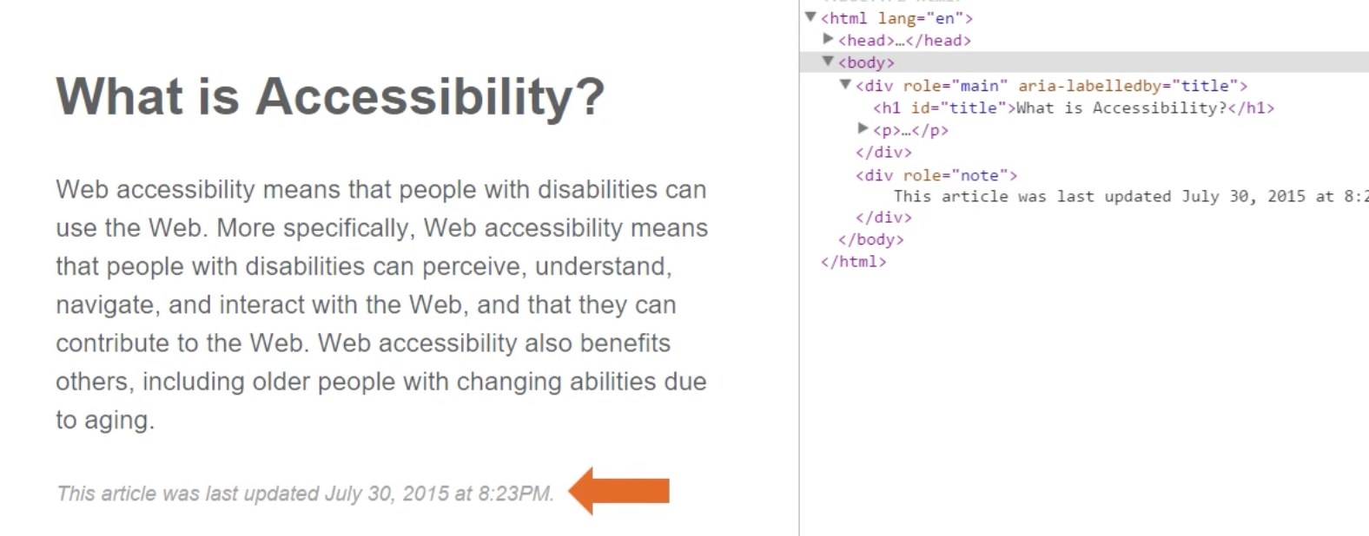

ARIA - its about filling gap what’s available in semantic code we are using.

